First Response Training
Thursday 23rd April 2020
Wadebridge Guide Hut
Goldworthy Way
Wadebridge
PL27 7DS

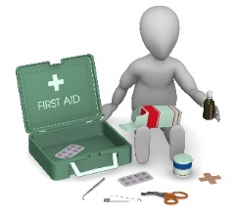
Attend a First Response and First Response Refresher, where you will be upskilled and gain your 1st Response Certificate, which remains valid for 3 years.

Where: Wadebridge Guide Hut

When: Thursday 23rd April 2020

Time: 7pm to 9.30pm

Cost is £6 for this session made payable to Cornwall Guide Association

Already hold a qualification?
Check if your external first aid qualification is suitable for Girlguiding.
If you hold a valid external first aid qualification you may already have the training you need to provide first aid support in guiding.

For your first aid qualification to be considered equivalent, it should:
- Be valid
- Have involved a training that was at least six hours long
- Included training for both adult and child CPR
- Covered all other topics in 1st Response training

A conversation with our county trainer Jean Whetham is required and she will need to explain the Girlguiding policies and procedures that you need to understand, this is a conversation based on trust, and you should share your certificates. Your record will then be updated on GO.

First Response Training

AIM:
The aim of 1st Response is to ensure that Girlguiding/Scouting members are kept as safe as possible while they are in our care.

Objectives:
By the end of the training participants will have had the opportunity to be:
- Provided with simple first aid information which is relevant to their role
- Helped to build confidence and skills in coping with emergency and first aid situations
- Equipped with the knowledge needed to manage these emergencies

Interested?
Fill out the application form & return with your unit cheque to:
Penny Congdon.
3 Grose Meadows,
St Dennis,
St Austell
Cornwall
PL26 8SG
Any queries – countyadmin@girlguidingcornwall.org.uk

